

**Assignment: 01**

| **Name: Farhan Ishrak** | **ID:22101766** | **Section: 21** |
| --- | --- | --- |

**Topic Name: Baseline Wandering, DC Components, Self Synchronization and Delta Modulation(DM)**

**Baseline Wandering**

If there are long strings of ones and zeros in the data, it drifts baseline and makes it tough for the receiver to decode the data correctly. This drift in the baseline is known as "baseline wandering".

* Receiver calculates the running average of received signal power.
* Average = baseline
* A long string of 0’s and 1’s can cause a drift in the baseline making it difficult for the receiver to decode properly.

**DC Components**

Signals create very low frequencies when the voltage level in a digital signal is constant for a while. These frequencies around zero are called DC components, creating problems for a system that cannot pass low frequencies or a system that uses electrical coupling.

* When the voltage level in a digital signal is constant for a while, the spectrum creates very low frequencies (results of Fourier analysis).
* If the signal is to pass through a system (such as a transformer) that does not allow the passage of a dc component, the signal is distorted and may create errors in the output.
* This component is extra energy residing on the line and is useless.

**Self Synchronization**

To match the sender and receiver clocks, hence match the bit intervals at both ends for correct decoding. Transitions in the digital signal act as self-synch altering the receiver to the start, mid, or end of the bit, resetting its clock in case it is out of sync.

* A self-synchronizing digital signal includes timing information in the data being transmitted.
* This can be achieved if there are transitions in the signal that alert the receiver to the beginning, middle, or end of the pulse.
* If the receiver’s clock is out of synchronization, these points can reset the clock.

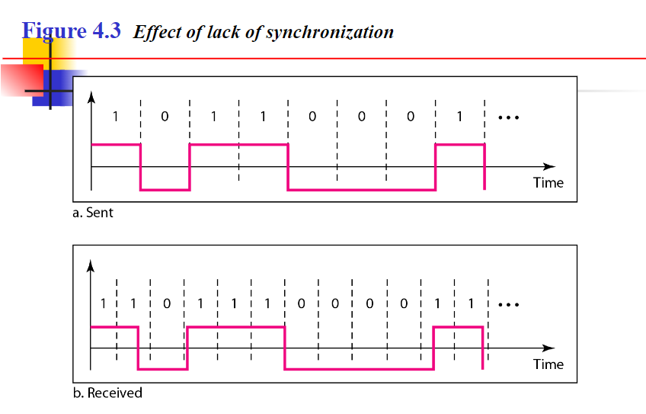

**Delta Modulation**

Delta modulation is a process mainly used in the transmission of voice information. It is a technique where analog-to-digital and digital-to-analog signal conversion are seen. Delta modulation (DM) is an easy way of DPCM. In this technique, the difference between consecutive signal samples is encoded into n-bit data streams. In DM, the data which is to be transmitted is minimized to a 1-bit data stream.

Advantages of Delta Modulation

* Design is easy and simple.
* It is a 1-bit quantizer.
* Modulator & demodulator can be designed easily.
* In delta modulation, the quantisation design is very simple
* The bit rate can be designed by the user

Disadvantages of Delta Modulation

* When the value of the delta is small, slope overload distortion is seen, which is a type of noise.
* When the value of delta is large, granular noise is seen, which is a type of noise.